14. Implement House price Prediction using appropriate machine learning algorithm

Aim
To implement a House Price Prediction Model using an appropriate machine learning algorithm in Python and predict the price of a house based on its features.

Algorithm
- Import the required libraries.
- Create a dataset containing house features and prices.
- Separate the input features and target price.
- Split the dataset into training and testing data.
- Create a Linear Regression model.
- Train the model using the training data.
- Predict house prices using the test data.
- Calculate the R² score to evaluate the model.
- Predict the price of a new house.

Code
from sklearn.linear_model import LinearRegression
from sklearn.model_selection import train_test_split
from sklearn.metrics import r2_score

X = [
[1000, 2, 1],
[1200, 2, 1],
[1500, 3, 2],
[1800, 3, 2],
[2000, 4, 2],
[2200, 4, 3],
[2500, 4, 3],
[2800, 5, 3],
[3000, 5, 4],
[3500, 6, 4]
]

y = [
3000000,
3500000,
4500000,
5200000,
6000000,
6800000,
7500000,
8500000,
9200000,
10500000
]

X_train, X_test, y_train, y_test = train_test_split(
X, y, test_size=0.2, random_state=42
)

model = LinearRegression()

model.fit(X_train, y_train)

y_pred = model.predict(X_test)

score = r2_score(y_test, y_pred)
print("Actual Prices:", y_test)
print("Predicted Prices:", y_pred)
print("R2 Score:", score)
new_house = [[2300, 4, 3]]
predicted_price = model.predict(new_house)

print("New House Details:", new_house)
print("Predicted House Price: Rs.", round(predicted_price[0], 2))
OUTPUT:
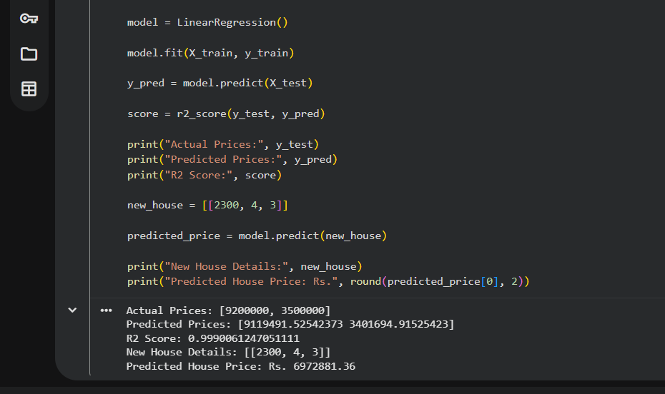

Result Statement
Thus, the House Price Prediction model was successfully implemented using the Linear Regression algorithm in Python, and the price of a new house was successfully predicted.

